|  |
| --- |
| OBJECTIVES |
| 1. What is Operating system explain its type in detail. 2. Different between Linux and Windows OS. |

PROCESDURE

* Task 1: **What is Operating system?**

An operating system acts as an intermediary between the user of a computer and computer hardware. The purpose of an operating system is to provide an environment in which a user can execute programs conveniently and efficiently. An operating system is a software that manages computer hardware. The hardware must provide appropriate mechanisms to ensure the correct operation of the computer system and to prevent user programs from interfering with the proper operation of the system.

* Task 2: Types of Operating Systems.

Some widely used operating systems are as follows-

* **Batch Operating System** This type of operating system does not interact with the computer directly. There is an operator which takes similar jobs having the same requirement and group them into batches. It is the responsibility of the operator to sort jobs with similar needs.

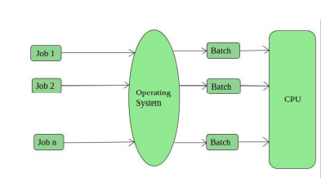

* **Time-Sharing Operating Systems** Each task is given some time to execute so that all the tasks work smoothly. Each user gets the time of CPU as they use a single system. These systems are also known as Multitasking Systems. The task can be from a single user or different users also. The time that each task gets to execute is called quantum. After this time interval is over OS switches over to the next task.

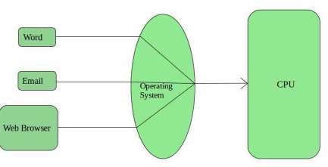

* 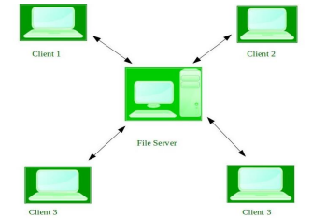**Network Operating System** These systems run on a server and provide the capability to manage data, users, groups, security, applications, and other networking functions. These

types of operating systems allow shared access of files, printers, security, applications, and other networking functions over a small private network. One more important aspect of Network Operating Systems is that all the users are well aware of the underlying configuration, of all other users within the network, their individual connections, etc. and that’s why these computers are popularly known as tightly coupled systems.

* 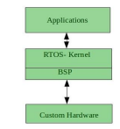**Real-Time Operating System** These types of Oss serve real-time systems. The time interval required to process and respond to inputs is very small. This time interval is called response time. Real-time systems are used when there are time requirements that are very strict like missile systems, air traffic control systems, robots, etc.

Two types of Real-Time Operating System which are as follows:

**Hard Real-Time Systems:** These OSs are meant for applications where time constraints are very strict and even the shortest possible delay is not acceptable. These systems are built for saving life like automatic parachutes or airbags which are required to be readily available in case of any accident. Virtual memory is rarely found in these systems.

**Soft Real-Time Systems:** These OSs are for applications where for time-constraint is less strict.

* Task 2: Different between Linux and Windows OS.

**Linux:** Linux could be a free and open supply OS supported operating system standards. It provides programming interface still as programmed compatible with operating system primarily based systems and provides giant selection applications. A UNIX operating system additionally contains several severally developed parts, leading to UNIX operating system that is totally compatible and free from proprietary code.

**Windows:** Windows may be a commissioned OS within which ASCII text file is inaccessible. it’s designed for the people with the angle of getting no programming information and for business and alternative industrial users. it’s terribly straightforward and simple to use. The distinction between Linux and Windows package is that Linux is completely freed from price whereas windows is marketable package and is expensive. Associate operating system could be a program meant to regulate the pc or computer hardware Associate behave as a treater between user and hardware.

Linux is an open supply package wherever users will access the ASCII text file and might improve the code victimization the system. On the opposite hand, in windows, users can’t access ASCII text file, and it’s an authorized OS.

|  |  |  |
| --- | --- | --- |
| S.NO | Linux | Windows |
| 1. | Linux is an opensource operating system. | While windows are the not the opensource operating system. |
| 2. | Linux is free of cost. | While it is costly. |
| 3 | It’s file name case-sensitive. | While its file name is case-insensitive. |
| 4 | In Linux, monolithic kernel is used. | While in this, micro kernel is used. |
| 5 | Linux is more efficient in comparison of windows. | While windows are less efficient. |
| 6 | There is forward slash is used for Separating the directories. | While there is back slash is used for Separating the directories. |
| 7 | Linux provides more security than windows. | While it provides less security than Linux. |
| 8 | Linux is widely used in hacking purpose-based systems | While windows do not provide much efficiency in hacking. |